**D15B/37** **Mikil Lalwani** **IP Lab 9**

**Aim -**

Experiment to study Advanced React.

**Theory-**

1. Router

React Router is a standard library for routing in React. It enables the navigation among views of various components in a React Application, allows changing the browser URL, and keeps the UI in sync with the URL.

Let us create a simple application to React to understand how the React Router works. The application will contain three components: the home component, the about a component, and the contact component. We will use React Router to navigate between these components.

1. Hooks

Hooks are the new feature introduced in the React 16.8 version. It allows you to use state and other React features without writing a class. Hooks are the functions that "hook into" React state and lifecycle features from function components. It does not work inside classes.

Hooks are backward-compatible, which means it does not contain any breaking changes. Also, it does not replace your knowledge of React concepts.

When to use a Hooks

If you write a function component, and then you want to add some state to it, previously you do this by converting it to a class. But, now you can do it by using a Hook inside the existing function component.

Rules of Hooks

Hooks are similar to JavaScript functions, but you need to follow these two rules when using them. The Hooks rule ensures that all the stateful logic in a component is visible in its source code. These rules are:

1. Only call Hooks at the top level

Do not call Hooks inside loops, conditions, or nested functions. Hooks should always be used at the top level of the React functions. This rule ensures that Hooks are called in the same order each time a component renders.

2. Only call Hooks from React functions

You cannot call Hooks from regular JavaScript functions. Instead, you can call Hooks from React function components. Hooks can also be called custom Hooks.

1. Refs

Refs are the shorthand used for references in React. It is similar to keys in React. It is an attribute that makes it possible to store a reference to particular DOM nodes or React elements. It provides a way to access React DOM nodes or React elements and how to interact with them. It is used when we want to change the value of a child component, without making use of props.

When to Use Refs

Refs can be used in the following cases:

When we need DOM measurements such as managing focus, text selection, or media playback.

It is used in triggering imperative animations.

When integrating with third-party DOM libraries.

It can also use as in callbacks.

When to not use Refs

Its use should be avoided for anything that can be done declaratively. For example, instead of using open() and close() methods on a Dialog component, you need to pass an isOpen prop to it.

You should have to avoid overuse of the Refs.

**Code-**

1. App.js

import React from 'react';

import Navbar from './Navbar.js';

import Product from './Product.js';

import Contact from './Contact.js';

import {BrowserRouter as Router,Routes,Route} from "react-router-dom";

function App() {

return (

<Router>

<div> <Navbar />

<Routes>

<Route path='/' element={<Product/>} />

<Route path='/contact' element={<Contact/>} />

</Routes>

</div> </Router>

);

}

export default App;

1. Navbar.js

import './Navbar.css';

import {Link} from 'react-router-dom';

function Navbar(){

return(

<>

<div>

<nav className="nav1">

<p className="navp1"><strong>Flipkart</strong></p>

<input className="navsearch1" type="text" placeholder="Search for products, brands and more" />

<button className="navlogin1">Login</button>

<p className="navtxt1">Become a Seller</p>

<p className="navtxt1"><Link style={{color:"white",textDecorationLine:"none"}} to="/contact">Contact us</Link></p>

<p className="navtxt1">Cart</p>

</nav>

</div>

<div>

<nav className="navbar2">

<div className="nav2imgtxt">

<img className="nav2img" src="https://rukminim1.flixcart.com/fk-p-flap/128/128/image/f0b3c58d99158fc3.png?q=100" alt="Loading" />

<p>Top Offers</p>

</div>

<div className="nav2imgtxt">

<img className="nav2img" src="https://rukminim1.flixcart.com/fk-p-flap/128/128/image/9bb3499c8248d2ba.png?q=100" alt="Loading" />

<p><Link to="/" style={{color:"black",textDecorationLine:"none"}}>Mobiles & Tablets</Link></p>

</div>

<div className="nav2imgtxt">

<img className="nav2img" src="https://rukminim1.flixcart.com/fk-p-flap/128/128/image/f8928124c04bc6e9.png?q=100" alt="Loading" />

<p>Electronics</p>

</div>

<div className="nav2imgtxt">

<img className="nav2img" src="https://rukminim1.flixcart.com/fk-p-flap/128/128/image/0d7278abbff8ba2a.png?q=100" alt="Loading" />

<p>TVs & Appliances</p>

</div>

<div className="nav2imgtxt">

<img className="nav2img" src="https://rukminim1.flixcart.com/fk-p-flap/128/128/image/a28598a782b6b4cf.png?q=100" alt="Loading" />

<p>Fashion</p>

</div>

<div className="nav2imgtxt">

<img className="nav2img" src="https://rukminim1.flixcart.com/fk-p-flap/128/128/image/a84e58e11c8b10b6.png?q=100" alt="Loading" />

<p>Beauty</p>

</div>

<div className="nav2imgtxt">

<img className="nav2img" src="https://rukminim1.flixcart.com/fk-p-flap/128/128/image/47874cd4acbfaf20.png?q=100" alt="Loading" />

<p>Home & Furniture</p>

</div>

<div className="nav2imgtxt">

<img className="nav2img" src="https://rukminim1.flixcart.com/fk-p-flap/128/128/image/a1140bead6bfd787.png?q=100" alt="Loading" />

<p>FK Originals</p>

</div>

<div className="nav2imgtxt">

<img className="nav2img" src="https://rukminim1.flixcart.com/fk-p-flap/128/128/image/705e339964226df2.png?q=100" alt="Loading" />

<p>Flights & Hotels</p>

</div>

<div className="nav2imgtxt">

<img className="nav2img" src="https://rukminim1.flixcart.com/fk-p-flap/128/128/image/5b09c4d0a60ecad7.png?q=100" alt="Loading" />

<p>Grocery</p>

</div>

</nav>

</div>

</>

);

}

export default Navbar;

**Screenshots-**

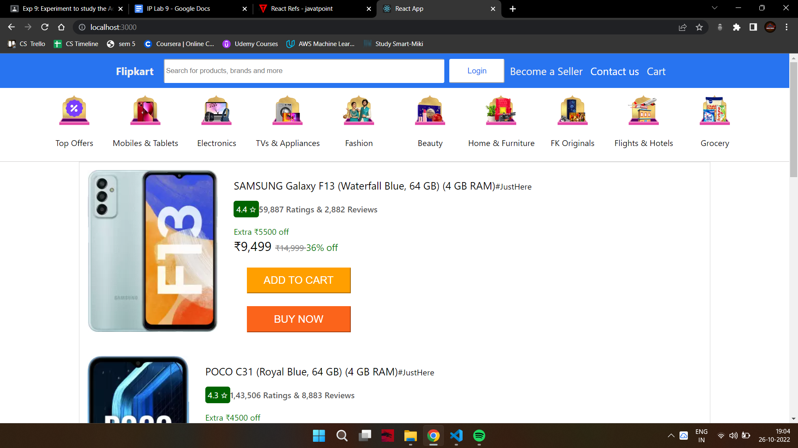

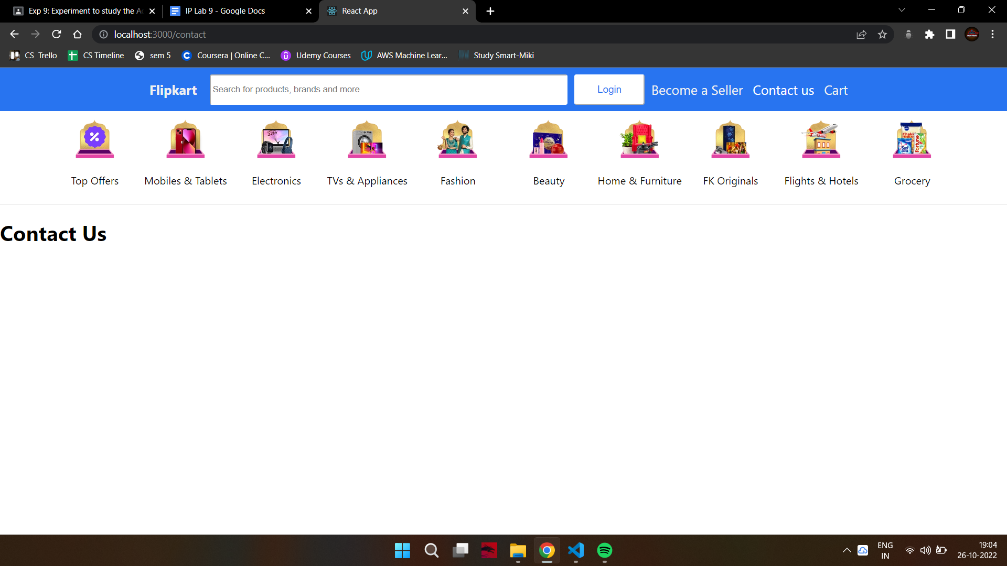**Conclusion-**

We have successfully completed the experiment.